-- Creating CUSTOMERS table

CREATE TABLE CUSTOMERS (

    CustomerID NUMBER PRIMARY KEY,

    Name VARCHAR2(100),

    Age NUMBER,

    Balance NUMBER,

    IsVIP CHAR(1)

);

-- Creating LOANS table

CREATE TABLE LOANS (

    LoanID NUMBER PRIMARY KEY,

    CustomerID NUMBER REFERENCES CUSTOMERS(CustomerID),

    InterestRate NUMBER,

    DueDate DATE

);

-- Inserting sample data

INSERT INTO CUSTOMERS VALUES (1, 'Sakthi', 65, 15000, 'N');

INSERT INTO CUSTOMERS VALUES (2, 'Varsha', 45, 8000, 'N');

INSERT INTO CUSTOMERS VALUES (3, 'Thamarai', 70, 12000, 'N');

INSERT INTO LOANS VALUES (101, 1, 7.5, SYSDATE + 10);

INSERT INTO LOANS VALUES (102, 2, 8.0, SYSDATE + 40);

INSERT INTO LOANS VALUES (103, 3, 6.5, SYSDATE + 5);

COMMIT;

SELECT * FROM CUSTOMERS;

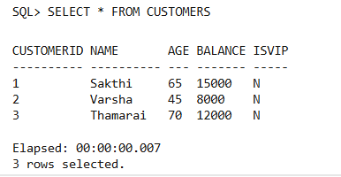

SELECT * FROM LOANS;

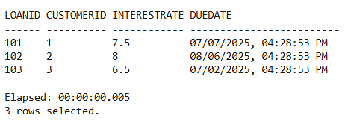

BEGIN

    FOR rec IN (

        SELECT l.LoanID, l.InterestRate

        FROM LOANS l

        JOIN CUSTOMERS c ON l.CustomerID = c.CustomerID

        WHERE c.Age > 60

    ) LOOP

        UPDATE LOANS

        SET InterestRate = InterestRate - 1

        WHERE LoanID = rec.LoanID;

    END LOOP;

    COMMIT;

    DBMS_OUTPUT.PUT_LINE('Discount applied to all eligible loans.');

END;

/ SELECT * FROM LOANS; 